Jack Barnet
IT management
Software Modelling & Analysis

Contents
Introduction 2
Functional/ non-functional Requirements 2
Case Diagram 4
Use case description 5
Activity diagram 7
Conclusion 8

Introduction
The aim of this system is to keep production moving and through the factory. It starts with material coming in and being scanned in by our stores’ people which is stored onto a database so everyone in the factory can check how much material is in the factory and see the weight in kilograms.
Parts are also produced from this material and once the parts are produced anyone can see what parts have been produced, where they have been stored and the quantity. SAP can also control how the sales are doing and what they produce money wise including profit and potential profit as all orders are received through here also.

Functional/ non-functional Requirements
Functional requirements
Stock Check | This checks how much material/parts are in the factory also how many are being created
Finance assistance | This checks how much money is being made on parts and being spent on materials
Customer problems | Customers can also see this to check track of what stage their products are at and can also communicate with us if there are problems
Incapable to enter errors | The system also won’t let you enter information wrong it has to be by part number and also by KG for material
Login | The system needs a username password and worker employee to enter if any of this information is wrong there is a prompt to try again this prevents tampering from employees and other users
Reset password | When a user of this system forgets their password there is a forgot password section as well that anyone can use
Non-Functional requirements
Ending result | The system also produces an end report including information about how long it takes and when it’s done and the usage of the material for each batch of parts
Tracking | The system also has tracking times for where the delivery vans are and when they will arrive at the factory and with customers
Suitability | SAP provides functions that meet any business needs and works around each company to help them with their needs

New Functional requirements
Performance | The system should have faster response times it’s a big database that is being loaded but the response time should be faster
Security | SAP should have better security or a way to also access stuff if the internet is offline recently Interplex had a security breach, and everything almost came to a standstill
New Non-Functional requirements
KPIs | I think it would be beneficial for there to be a KPIs section on SAP to see if we are hitting targets and meeting requirements for further progression in the company and improved customer service
Usability | Sap could be made easier to use for new users it can be confusing more user interfaces and clearer diagrams

Case Diagram
This is a case diagram that I have made to walk through the steps that are done so a customer can order parts and how it is communicated with Interplex.

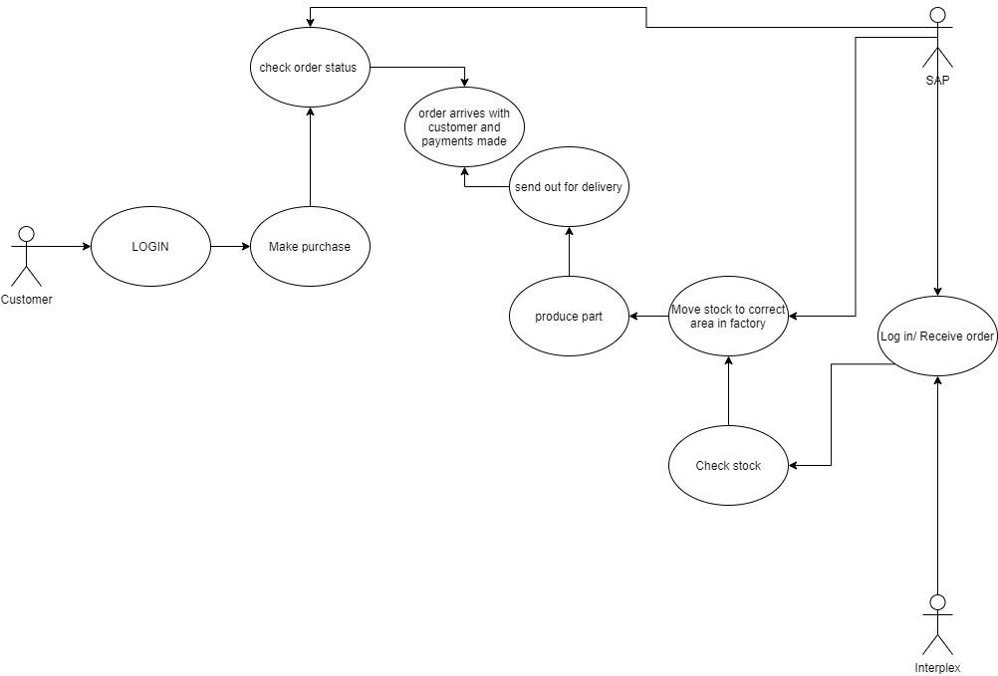

Use case description
USE CASE DESCRIPTION
Trigger
 | Material arrives
Actors
 | Interplex
 | SAP
Preconditions
 | Secure connection to database
 | Material is used
Goals
 | Produce parts
Check Material
 | Actor | Activity | Alternative Flow
1 | Interplex | Logs in
2 | SAP | Reads the details from the user |  | A1
3 | SAP | Verifies password
4 | Interplex | Inserts how much material is delivered |  | A2
5 | SAP | Receives how much material is already in and adds it to
6 | SAP | The system adds on how much material has arrived
7 | Interplex | Moves material to the located area
8 | SAP | Receives information and moves it to a dedicated machine
9 | Interplex | Takes produced parts and scan them to location
10 | SAP | Sends information to location to be sent out for delivery

A1 – Wrong password entered
 | Actor | Activity | Alt Flow
1 | System | The wrong password is entered
2 | System | Displays wrong password is entered
3 | System | Returns to step 1 in the main flow

A2 – Material isn’t entered in KG
 | Actor | Activity | Alt Flow
1 | System | Notifies the user material amount must be in KG
2 | System | Displays that material amount must be in KG
3 | System | Returns to step 4 in the main flow

Activity diagram

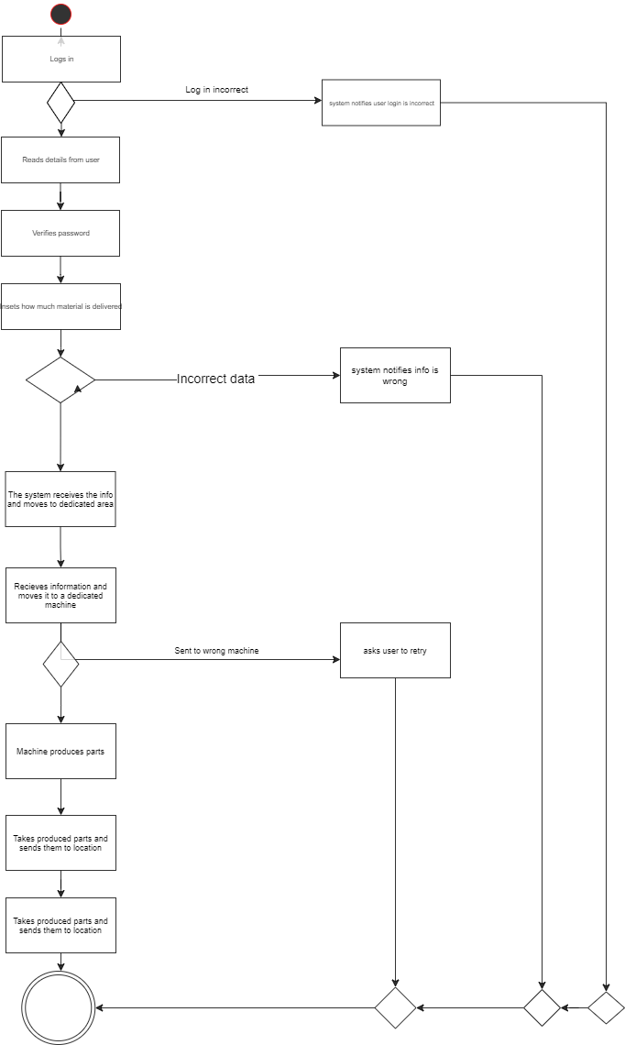

Conclusion

I think both diagrams are important in different situations I would normally go with the activity diagram as its easier to understand as it flows down, and you can see the direction it flows in and also all the places it can go wrong, but there are also benefits to a use case diagram if it uses more than 2 people it can show where all users links. A use case diagram is good for specifying the system and getting the requirements.
There are disadvantages of having a use case diagram as there is poor flow and indication also it can be hard to fit in information on this compared to an activity diagram. Activity diagrams are easier to understand for both analysts and customers they can also add different conditions and multiple actors which is useful if there is more than one actor. There are also disadvantages to this because it is hard to add extra stuff to it.
Personally, I would use an activity diagram just for reasons as stated above and for the easiness and how straightforward it is to follow, and it clearly states possible errors and where errors can be found.

